🟣 1. ALLERGY (Health)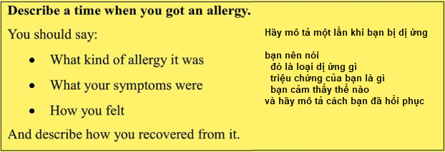I would like to talk about a time when I had an allergy. It happened about one year ago when I ate seafood with my friends. After a few hours, my skin became red and very itchy. I also felt a little tired and uncomfortable.
At first, I did not know what was happening, so I felt quite worried. I decided to go to a clinic. The doctor told me that I was allergic to shrimp. He gave me some medicine, and after a few days, I felt better.
After that experience, I became more careful about what I eat. Now, when I go to a restaurant, I always ask about the ingredients. This experience taught me that health is very important, and we should listen to our body.

🟤 2. HISTORICAL SITE (Culture)
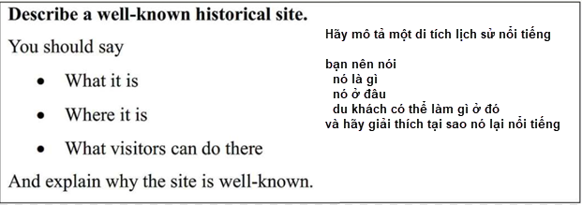I would like to talk about the Temple of Literature in Hanoi. It is one of the most famous historical places in Vietnam.
It was built a long time ago and is known as the first university in Vietnam. Many students visit this place before important exams because they hope to have good results.
When I visited it, I felt very peaceful. The buildings are traditional and beautiful. It helped me understand more about Vietnamese history and culture.
I think this place is important because it shows that Vietnamese people always respect education. We should protect places like this for future generations.

✅ NHÓM 3: SELF DEVELOPMENT / PERSONAL GROWTH
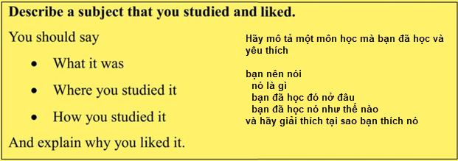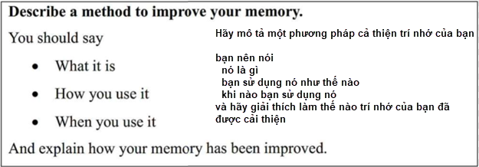
I would like to talk about English, which is a subject I really like.
At first, I found it quite difficult, especially remembering new vocabulary. I often forgot words after a few days, so I felt a bit discouraged.
To improve, I changed my learning method. I started writing new words in a notebook and reviewed them every night for about 10 minutes. I also tried to use those words when speaking or writing simple sentences.
After some time, I could remember vocabulary much better and felt more confident when speaking English. Because of that, I started to enjoy this subject more and more.
In my opinion, when we find the right method, learning becomes easier and more interesting.

✅ NHÓM 4: FOOD & DAILY LIFE / FOOD & GLOBALIZATION
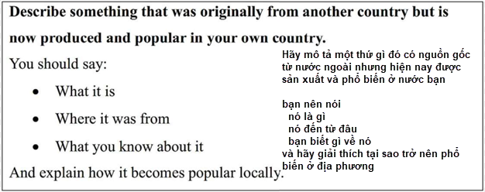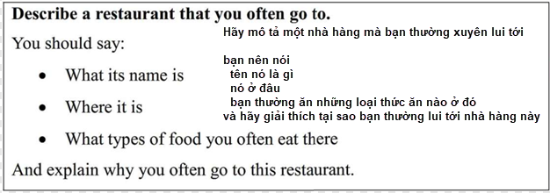
I would like to talk about a restaurant I often go to and a type of food that is very popular there, which is pizza.
The restaurant is near my house. It is not very big, but it is clean and comfortable. I usually go there with my friends on weekends. The staff are friendly, and the price is reasonable.
Pizza originally comes from Italy, but now many Vietnamese people enjoy it. I think it became popular because young people like trying foreign food and Western culture.
When I eat there, I feel relaxed and happy because I can talk with my friends and enjoy good food.
In my opinion, restaurants like this show how different cultures can mix together through food.

✅ NHÓM 5: TECHNOLOGY & SUCCESS 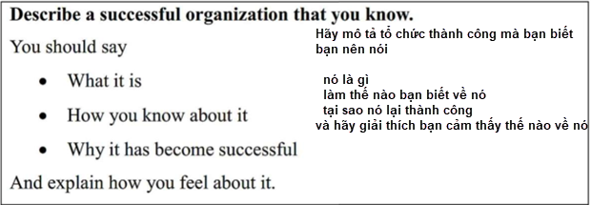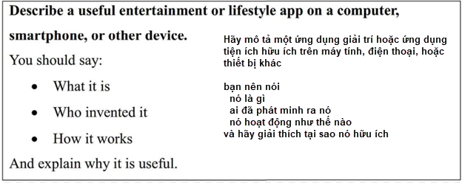
I would like to talk about YouTube, which is a very useful app in my daily life. I use it almost every day to watch educational videos and improve my English.
It helps me learn many things at home and saves a lot of time. The app is simple and easy to use, so many people like it.
YouTube belongs to Google, which is one of the most successful technology companies in the world. Google is successful because it creates useful products and always tries to improve its services.
In my opinion, the success of this company comes from understanding users’ needs and providing free and helpful information.
However, we should use technology wisely and not spend too much time on it.

✅ NHÓM 6: ENVIRONMENT PROBLEMS 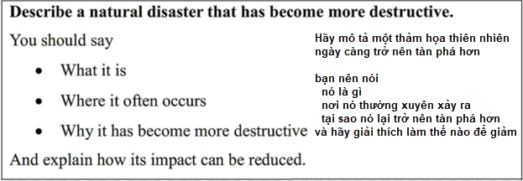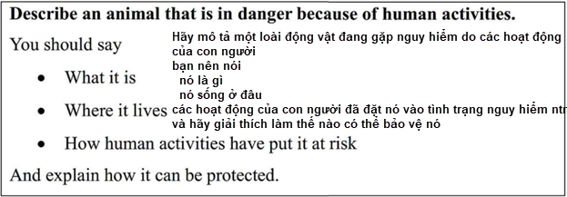 I would like to talk about environmental problems, especially floods and endangered animals.
In recent years, floods have become more serious. Heavy rain can cause big floods, and many houses are damaged. People sometimes lose their homes.
Besides that, animals like tigers are in danger because people cut down forests and hunt illegally. When forests disappear, animals lose their homes.
I think these problems happen because people care too much about development and forget to protect nature.
To solve this problem, the government should make stronger laws, and people should be more responsible.
If we do not act now, the situation will become worse in the future.

